We can parameterize Postman requests to execute the same request with various sets of data. This is done with the help of variables along with parameters. A parameter is a part of the URL used to pass more information to the server.

The data can be used in the form of a data file or an Environment variable. Parameterization is an important feature of Postman and helps to eliminate redundant tests. Parameters are enclosed in double curly braces {{parameter}}.

Let us take an example of an URL:[**https://www.tutorialspoint.com/index.htm**](https://www.tutorialspoint.com/index.htm). We shall create a variable as URL then use it for parameterization of the request. We can refer to it in the format {{url}} in Postman.

A parameter is in the form of a key-value pair. So to point to the URL:[**https://www.tutorialspoint.com/index.htm**](https://www.tutorialspoint.com/index.htm), we can mention it as {{url}}/index.htm. So here, the URL is the key and the value set is [**https://www.tutorialspoint.com.**](https://www.tutorialspoint.com./)

Create a Parameter Request

**Step1** − Click on the eye icon to the right of the Environment dropdown in the top right corner in the Postman application.

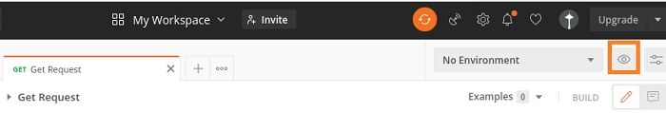

**Step 2** − Click on the Edit link in the Globals section

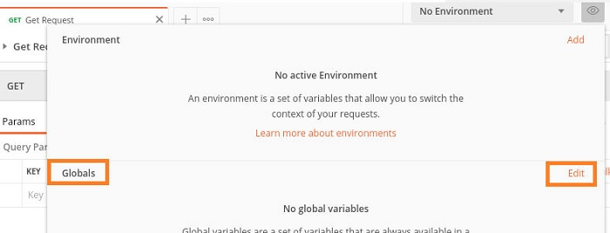

**Step 3** − MANAGE ENVIRONMENTS pop-up comes up. Enter URL for the VARIABLE field and [**https://www.tutorialspoint.com**](https://www.tutorialspoint.com/) for INITIAL VALUE. Then click on Save.

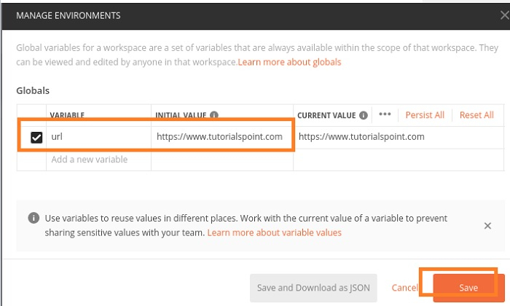

**Step 4** − Click on close to move to the next screen.

**Step 5** − In the Http Request tab, enter {{url}}/index.htm in the address bar. Select the GET method and click on Send.

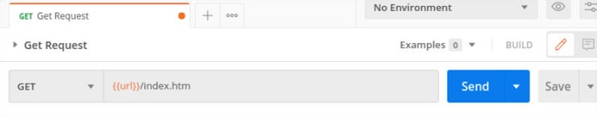

Response

Once a request has been sent, we can see the response code 200 OK populated in the Response. This signifies a successful request and a correct endpoint.

